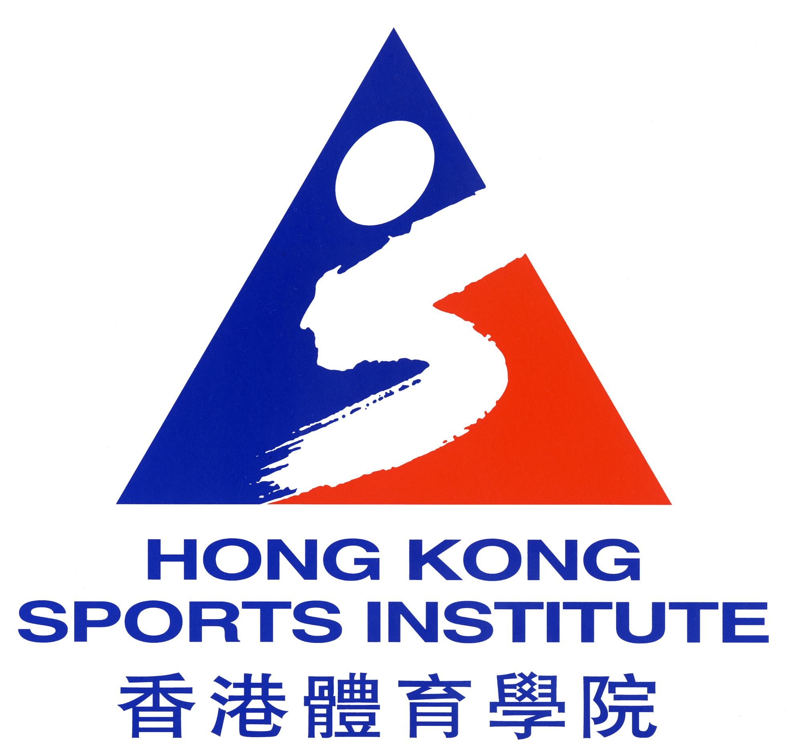
ELITE TRAINING GRANT/

INDIVIDUAL ATHLETES SUPPORT SCHEME/
SPORTS AID GRANT
Application Form
2020-2021

The information you provide in this application form is the basis for assessing eligibility for assistance under the Elite Training Grant (ETG)/Individual Athletes Support Scheme (IASS)/Sports Aid Grant (SAG). The Application Guidelines should be read in conjunction with the explanatory notes when completing this application form. Application form and Guidelines can be downloaded from the HKSI website (www.hksi.org.hk).
The personal data provided will only be used by the HKSI for purposes relating to this application. Only persons duly authorised by the HKSI will be given access to your personal data. For correction of or access to the personal data you have submitted, please contact the staff of the High Performance Administration Department.
Please submit the completed form to High Performance Administration Department, Hong Kong Sports Institute, 25 Yuen Wo Road, Shatin, Hong Kong on or before 1 November 2019. Performance attained between 2 November and 31 December 2019 should be reported on or before 3 January 2020, if any. Late or incomplete applications will NOT be considered.

PART A (To be completed by the applicant) (Please type or print)
1. Fund(s) Applied ◻ Elite Training Grant¹
◻ Individual Athletes Support Scheme²
◻ *Sports Aid Grant³/ Sports Aid Grant (Team Only Sports)
Sport: ◻ Full Time Training ◻ Part Time Training
2. Personal Particulars

Name: (English) (Surname) (Other Name)
(as per your HK ID Card/Passport)

Name: (Chinese) Gender: * Male / Female Age:

Date of birth: (dd) (mm) (yyyy) Place of birth:

Nationality: Hong Kong ID No.:

Residence in HK since: (dd) (mm) (yyyy) Occupation: _______________ (*Full/Part Time)

School (if you are currently studying) :
(*Primary School / Secondary School / Post-Secondary Institute)
Postal address:

___________________________________________ Day-time contact tel. no.:

Email address:

Emergency Contact Person : Telephone Number :

Squad: Hong Kong National * Senior/Elite/Junior member Position in Team:
(For applicants of SAG – Team Only Sports)

* Delete as inappropriate

Remarks: 1. Athletes of Tier A sports and sports supported under the IASS can apply for ETG.
2. Athletes of Olympic or Asian Games Sports, who are not supported under Tier A sports but meet the specified
funding criteria can apply for IASS (who will receive ETG and a programme grant).
- Athletes of other sports which are not supported under Tier A sports or IASS can apply for SAG.
3. Records of Achievements

- Provide information on your best performances at international/major local competitions in which you have competed in the period between January 2018 to December 2019. Results achieved after December 2019 will be considered for support in 2021-2022.
- In accordance with the Selection Criteria, please list the achievements in order of merit
- Support all your achievements with documentation (e.g. official results, press reviews, etc.)
- Use separate sheet if additional writing space is required

A. Individual Results

Date  (dd/mm/yyyy) | Name of Competition / Venue  (Please provide both English and Chinese versions for data input) | Event  (e.g. 100m , singles, etc.)  (Please provide both English and Chinese versions  for data input) | Results/ Position  (e.g. score, timing,  distance in metre, etc.) | No. of  Entries  for your Event | No. of Competing  Countries/Regions  for your Event | Personal Best  for this Event

B. 1. Team Results (The applicant as a member of the team)

Date  (dd/mm/yyyy) | Name of Competition / Venue  (Please provide both English and Chinese versions for data input) | Event  (e.g. relay, doubles, etc.)  (Please provide both English and Chinese versions for data input) | Results/ Position  (e.g. score, timing,  distance in metre, etc.) | No. of  Entries  for your Event | No. of Competing Countries/Regions  for your Event | Name(s) of  Team  Member(s)  (Please provide both English and Chinese versions for data input)

2. Individual Award Honoured in Major Competition (Refer to special consideration for support to Team Sports/Events)

Date  (dd/mm/yyyy) | Name of Competition/Venue  (Please provide both English and Chinese versions for data input) | Award  (Please provide both English and Chinese versions for data input)

C. Ranking

Ranking should be supported by officially published/endorsed ranking lists of Asian/International Federation.

2018 : |  | (Asian) |  | (World)
2019 : |  | (Asian) |  | (World)

4. Training programme for 2020-2021 (To be agreed by your Coaching Supervisor)
- Please state venue, frequency, duration, months on total, etc.

5. Competition plan for 2020-2021 (To be agreed by your Coaching Supervisor)
- Please state name of competition, date, place, targets to be achieved.

6. Major competitions and goals in the next 4 years (To be agreed by your Coaching Supervisor)
(Please provide both English and Chinese versions)

7. Assistance received in 2019-2020

* ETG / IASS |  | Yes | Category: | * Elite A+ / Elite A / Elite B /
 |  |  |  | Elite B+ / Elite C/ Senior Squad /
 |  |  |  | Junior A / Junior B / Junior Squad
 |  |  |  | Secondary Student Athlete A /
 |  |  |  | Secondary Student Athlete B /
 |  |  |  | Secondary Student Athlete Squad
 |  | No

SAG |  | Yes | Category: | * Elite A / Elite B / Elite C/
 |  |  |  | Junior A / Junior B
 |  |  |  | * Elite A (Team) / Elite B (Team) / Elite C (Team)
 |  |  |  | Junior A (Team) / Junior B (Team)
 |  | No

* Delete as inappropriate

8. Declaration

I declare that the information I have provided in this application is true and correct. I understand that non-conformity with the submitted training and competition plan [as listed in (4) and (5)] for the year 2020-2021 without valid reasons, or breach of terms in the Agreement might result in cessation of funding and a refund in whole or in part of the payment.

Signature of applicant: _________________________ Date: __________________

PART B To be completed by the NSA applying for SAG “Team Only Sports” Grant

- Justification for Nomination

- Selection Criteria for Nominated Athlete(s)

- Selection Procedure for Nominated Athlete(s)

- Development Plan for the Athlete(s) to Achieve Excellence

- Budget for the Proposed Training/Support Programme (Please list budget breakdown and amount required in Hong Kong dollars)

Amount of Grant Required: $ __________________________________
(The maximum grant is HK$50,160 per “Team Only Sports” NSA)

PART C Parental/Guardian Consent (For applicants under 18 years old)
(To be completed by parent/guardian)

I consent to my child/ward, ____________________________ (Name) being assisted by the *Elite Training Grant/ Individual Athletes Support Scheme /Sports Aid Grant, and I *agree/do not agree to let *him/her attend training and competitions as shown on the submitted schedule. I understand that non-conformity with the submitted schedule [as listed in (4) and (5)] without valid reasons, or breach of terms in the Agreement might result in cessation of funding and a refund in whole or in part of the payment.

Signature of parent/guardian: ___________________________________________________________
Name in BLOCK letters: ____________________________ Relationship: ___________________
Address (if different from applicant): _____________________________________________________
______________________________________ Day-time contact tel. no.: _______________________

PART D Recommendation of the Coaching Supervisor

Name of Coaching Supervisor: (English) (Surname) (Other name)

(Chinese) (*Mr/Ms/Miss)
Address:
Email address : Day-time contact tel. no.:
Qualification:
Position at National Sports Association:

Please provide comments on the applicant in the following areas with grading:
(A - Excellent, B - Good, C - Satisfactory, D - Fair)
 |  |  |  |  |  |  |  |  | A |  | B |  | C |  | D
(i) Commitment to training and competitions
(ii) Potential for further advancement
(iii) Consistent level of performance
(iv) Contribution to team work

Other Comments/Recommendations:
(if any)

Signature: _______________________________________ Date: _____________________________

* Delete as inappropriate

PART E Endorsement by the National Sports Association (NSA)
(To be endorsed and signed by a senior official e.g. President, Chairman, Hon
Secretary of the NSA)

Name of Association: _______________________________________________________________________

Name of Responsible Person: (English) (Surname) (Other name)

(Chinese) (*Mr/Ms/Miss)

Position at NSA:
Address: _________________________________________________________________________________

___________________________________________________ Tel. no. _____________________________

Fax no.: ______________________ Email address: __________________________________________

* * * * *

1. Comments/Recommendations on the applicant:

- I hereby certify that the information given above is true and correct and I *endorse/do not endorse the application.
(Please state reason(s) if you do not endorse the application.)

3. I *endorse/do not endorse the appointment of ________________________________ as the coaching supervisor of the applicant.

* Delete as inappropriate

Signature of Official :
Name (English) : (Surname) (Other name)
(Chinese) :
Position at NSA :
Tel. no: __________________________________
Fax no.: __________________________________
Email: ___________________________________

Date : Association’s Chop: ______________________

